Energy Budget for Stream Temperature Using SNTemp Output

Jake Zwart (with input from others); 2019-10-01

**Energy budget**

Stream temperature (*Tw*) can be calculated using an energy mass balance model which accounts for the effect of inflows (upstream, groundwater, surface runoff), outflows, and surface heating and cooling on heat transfer in each stream segment (Dugdale et al. 2017):

$\frac{dTemp}{dt}=-U\frac{dTemp}{dx}+ D_{L}\frac{d^{2}Temp}{dx^{2}}+ \frac{S}{ρ_{w}×c_{w}×z}$ (1)

Or simplified version (Herbert et al. 2011):

$\frac{∂T_{w}}{∂t}= \frac{W*S}{c_{w}ρ_{w}A}$ (1a)

where *S* is the rate of change of heat stored in the stream segment (W m-2), *A* is stream segment cross-sectional area (m2), *W* is the stream segment width (m), $ρ_{W}$ is the density of water (1000 kg m-3), and is the specific heat of water (4186 J kg-1 deg C-1). The energy budget for each stream segment is formulated as:

$S=R_{net}+Q_{bed}+A_{net}-(E+H)$ (2)

where $R_{net}$ is net radiation, $Q_{bed}$ is heat fluxes to or from the river bed, $A_{net}$ is net heat advected into each stream segment (e.g. groundwater, upstream inflow), and *E* and *H* are evaporative and sensible heat fluxes, respectively. We will assume that heat fluxes to or from the river bed is negligible, which is assumed in many stream temperature models [Dugdale et al. 2017] (Qbed = 0).

***Radiative heat fluxes***

*Rnet* is calculated as:

$R_{net}=R_{swd}×\left(1-α_{sw}\right)+R_{lwd}×\left(1-α_{lw}\right)-R_{lwu}$ (3)

Where $α_{sw}$ is the shortwave albedo of water (0.07), $α_{lw}$ is the longwave albedo of water (0.03), *Rswd*is the mean daily downward shortwave radiation, *Rlwd* is the mean daily downward longwave radiation, and *Rlwu* is the reflected longwave radiation, calculated as:

$R_{lwu}=ε×σ×{(T_{w}+273.15)}^{4}$ (4)

Where $ε$ is the emissivity of the water surface (0.97), and $σ$ is the Stefan-Boltzmann constant (5.6697x10-8 W m-2 K-4).

***Latent and sensible heat fluxes***

Latent heat flux (*E*) is estimated as:

$E=\left(a+bV\right) × (e_{s}- e_{a})$

Where *a* and *b* are empirical constants, *V* is wind speed (m s-1), is the saturated vapor pressure, and $e_{a}$ is the water vapor pressure.

$e_{s}= {10}^{\left(9.28603523\frac{2322.37885}{T_{w}+273.15}\right)}$

$e_{a}= \left(\frac{RH}{100}\right)e_{s}$

Sensible heat flux (*H*) is estimated as a function of the latent heat (E) and the Bowen ratio (β):

$H=E×β$

$β=0.61\left(\frac{P}{1000}\right)\left(\frac{T_{w}-T_{a}}{e_{s}-e_{a}}\right)$

Where *P* is the air pressure (mbar), *Tw* is stream water temperature, and *Ta* is the air water temperature.

**Advected heat**

Net heat advected into each stream segment through water was calculated as the sum of heat transfer from all water fluxes:

$A_{net}=A_{rain}+A_{GW}+A_{upstream}+A_{sroff}+A_{ss}-A_{outflow}-A_{evap}$

Where:

$A_{rain}=ρ_{W}×c_{W}×seg_rain ×seg_width×seg_length ×seg_tave_air÷86400$

$A_{GW}=ρ_{W}×c_{W}×seginc_gwflow×seg_tave_gw$

$A_{upstream}=ρ_{W}×c_{W}×seg_upstream_inflow×seg_tave_upstream$

$A_{sroff}=ρ_{W}×c_{W}×seginc_sroff×seg_tave_sroff$

$A_{ss}=ρ_{W}×c_{W}×seginc_ssflow×seg_tave_ss$

$A_{outflow}=ρ_{W}×c_{W}×seg_outflow×seg_tave_water$

$A_{evap}=ρ_{W}×c_{W}×\left(\frac{seginc_potet×seg_width×seg_length÷86400 }{ρ_{w}×L_{v}}\right)×seg_tave_water$

Where $L_{v}$ is the latent heat of vaporization (2.46x106 J kg-1).

Energy budget –

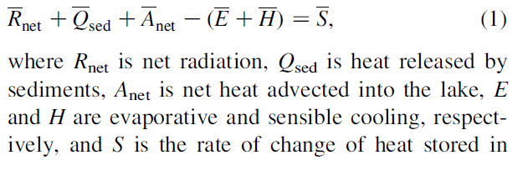

Need:

seg_rain (and rain temp – could use air temp), seg_gwflow ( and gw_temp), seg_evap (stream temp), seg_inflow (and inflow temp), seg_ss ( and ss temp), seg_sroff (and sroff temp),

seginc_gwflow, seginc_sroff, seginc_ssflow, seginc_swrad, seginc_potet

|  |  |  |
| --- | --- | --- |
| **Component** | **Volume** | **Temperature** |
| Rain | seg_rain (inches) * area (seg_width [m] * length [m]) | seg_tave_air (degrees C) |
| Groundwater | seginc_gwflow (cfs) | seg_tave_gw (degrees C) |
| Surface Runoff | seginc_sroff (cfs) | seg_tave_sroff (degrees C) |
| Subsurface Runoff | seginc_ssflow (cfs) | seg_tave_ss (degrees C) |
| Upstream Inflow | seg_upstream_inflow (cfs) | seg_tave_upstream (degrees C) |
| Evaporation | seg_potet (inches) * area (seg_width [m] * length [m]) | seg_tave_water (degrees C) |
| Outflow | seg_outflow (cfs) | seg_tave_water (degrees C) |

**Dynamics parameters to output from PRMS – SNTemp**

seg_rain, seg_width, seg_tave_air, seginc_gwflow, seg_tave_gw, seginc_sroff, seg_tave_sroff, seginc_ssflow, seg_tave_ss, seg_upstream_inflow, seg_tave_upstream, seg_potet, seg_tave_water, seg_outflow, seg_swrad

**Static parameters:**

Segment length

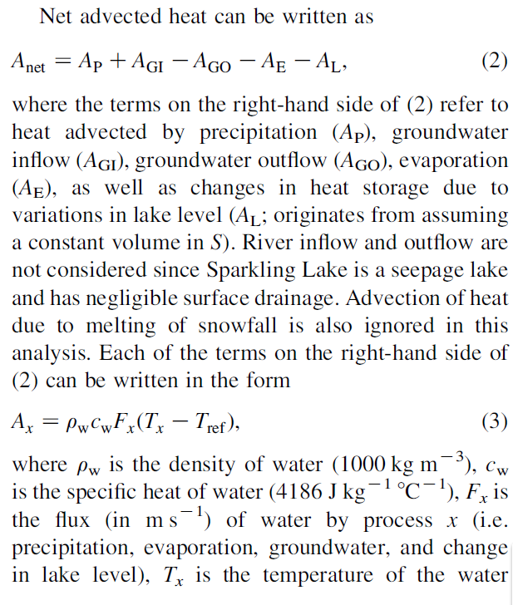

|  |  |  |  |  |
| --- | --- | --- | --- | --- |
| ρW | Density of water | kg m-3 | 1000 |  |
| cw | Specific heat of water | J kg-1 deg C-1 | 4186 |  |
|  |  |  |  |  |